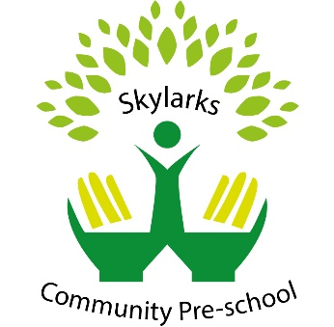
Intimate care and nappy changing

Policy statement

No child is excluded from participating in our setting who may, for any reason, not yet be toilet trained and who may still be wearing nappies or equivalent. We work with parents towards toilet training, unless there are medical or other developmental reasons why this may not be appropriate at the time.

We provide nappy changing facilities and exercise good hygiene practices in order to accommodate children who are not, yet toilet trained.

We see toilet training as a self-care skill that children have the opportunity to learn with the full support and non-judgemental concern of adults.

This policy was adopted by | Skylarks Community Preschool | (name of provider)
On | 1st August 2022 | (date)
Date to be reviewed | 1st August 2023 | (date)
Signed on behalf of the provider
Name of signatory | Kathleen Thomson
Role of signatory (e.g. chair, director or owner) | Manager/Trustee

Date Reviewed | Changes | Signature
7th August 2024 | N/A
14th August 2025 | N/A

